BR_LMS_08- User(Student/Academic Staff) Registration
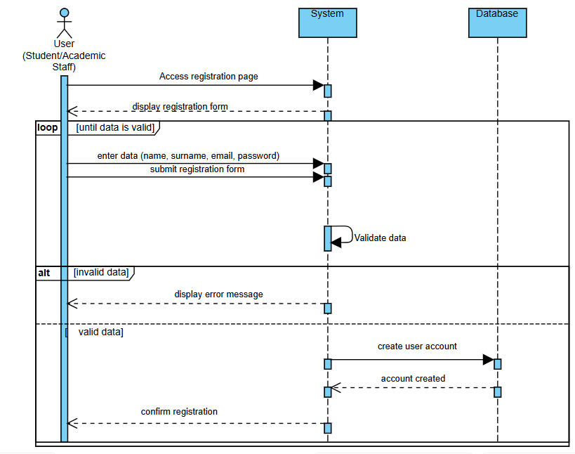

BR_LMS_09 – Administrator Account Management
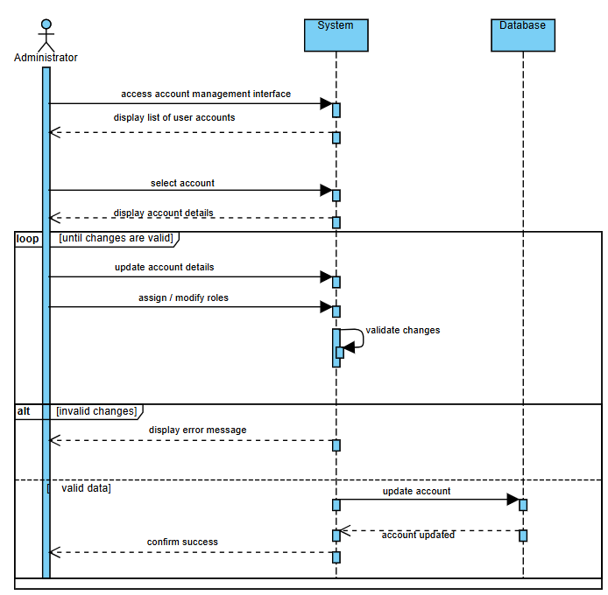

BR_LMS_10- Manage User Profile

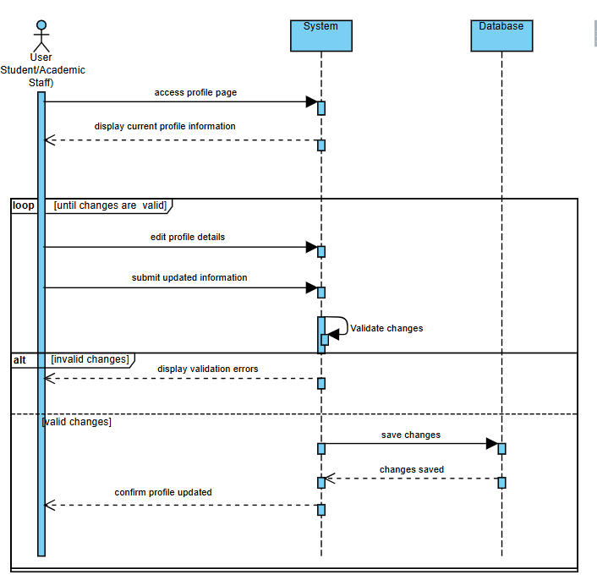

BR_LMS_11- Track System Activity
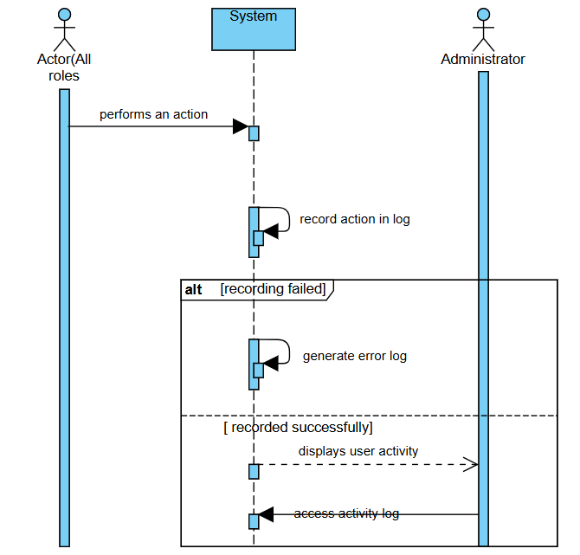

BR_LMS_12 – Library Event Management
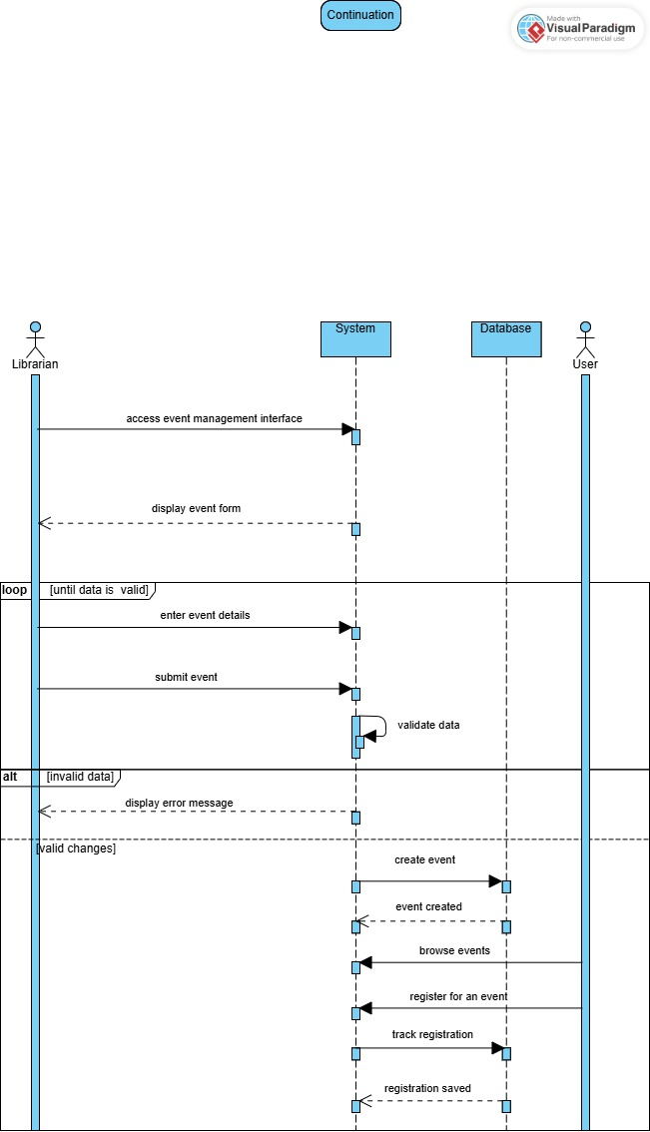

BR_LMS_13 — Manage Lost and Found Items
